**What's Cooking Release 1 Scenarios**

**Group 2: Hrishikesh Badve, Sudhanshu Basuroy, Utsav Sharma, Mridvika Suresh**

The What’s Cooking (formerly Smart Grocery) application will allow users to view recipes based on the ingredients they have at home. One of its key features is the ability to help users discover new and exciting recipes based on the ingredients they already have at home. In addition to the recipe discovery feature, the What’s Cooking application allows users to create lists of their favorite recipes, view recipes from their favorite chefs and suggest alternative ingredients for recipes in case a user is missing a specific item.

When the user enters the application, they will be given 2 primary options that are the crux of our 2 scenarios for this release. One button is for the “Recipe Recommendation” that suggests recipes to users based on input added by the user. The other button, “Recipe Exploration” is for users to view the recipes. The goal of the application is to make the process intuitive and visually appealing. The specific scenarios are as follows:

**Scenario “Recipe Recommendation”**

When the user selects the “Recipe Recommendation” option, the application navigates to a dropdown menu that allows the user to select up to 5 ingredients from a predefined ingredient list of 10. Once the user confirms the ingredients that they have, the application will show them a list of recipes containing those ingredients.

This system interacts with the firebase database, retrieving recipes that match the ingredients provided by the user. This database will be crucial for efficiently retrieving relevant recipes based on the ingredients provided by the users. The database includes one main table, highlighting each recipe along with ingredients required. The table structure is given below:

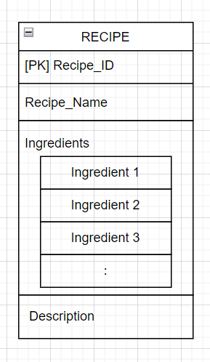

**Scenario “Recipe Exploration”**

When the user opens the application, they are presented with a variety of options to navigate to.

When the user selects “Recipe Exploration” from these options, they are presented with a list of recipes that will be stored in our database. The recipe options provided here will be similar to the ones provided in the recommendation system for this release. The users can then scroll through and click on a specific recipe, where a new page will be shown to the user containing an image, a detailed ingredient list and preparation steps.

The overall flow we aim to achieve at the end of release 1 is as follows:

